Leader Overview
Our God can do anything He chooses. He is almighty and all powerful. No one can do the things that God can. But still He chooses for you and me to be part of His plan. Because of who He is, we can do whatever He is asking us to, even if we are afraid. When we obey Him, His Holy Spirit gives us strength. He believes in us.

Bible Lesson
Gideon Becomes Judge
Judges 6:11–16, 36–40
Faith Fact
God believes in me.
Faith Verse
Isaiah 41:10 (NLT)
“Don’t be afraid, for I am with you. Don’t be discouraged, for I am your God. I will strengthen you and help you. I will hold you up with my victorious right hand.”

Preparing for the Session
Leader Preparation Time: 20–25 Minutes
You Will Need
Large Group
- Bible
- Worship songs (Song suggestions: “Real Love” by Hillsong Young & Free; “Chain Reaction” by River Valley Worship; “Good Good Father” by Chris Tomlin)
- For groups not using a phone or tablet only, add:
• Projector or TV
• Laptop
• Rules Video or Slide
• Faith Fact Slide
• Faith Verse Video or Slide
• Countdown60 Video–60 seconds
• Bible Lesson Video A
• Bible Lesson Video B
• Bible Lesson Slides 1–6
• Optional: Jar, horn, and torch
Small Group
- Small Group Activity Page, (2 pages) one per kid
- Activity Page 3
- Small Group Group Connection page, one per group
- Set of 3 cups, one set per group
- Tape
- Paper towel tube (empty), one per group
- Colored tissue paper (red, yellow, and orange to represent fire)
- Scissors
- Glue sticks
- Colors or markers

To download session videos, slides, and printables, visit: BibleEngagementProject.com/downloads

Getting Ready
Large Group
• Download videos and slides if needed.
• Select worship song(s) and have them ready to play.
Small Group
• Print the Small Group Activity Page (2 pages), one per kid.
• Print Activity Page 3, so each kid can have a torch.
• Print the Small Group Group Connection page and cut apart the torches.
• Tape small paper torch inside cup, one per group.
• Create torch, one per group.
• Cut out craft torch, one per kid.

First time leading Listen for Kids? Check out the Facilitator Guide.
Large Group
30 Minutes
See what’s needed at the beginning of the session.

Introduction
Welcome! I’m so glad you’re here! Have you ever played a game where kids were picked for teams? Were you afraid that you may not get picked or that you’d be picked last? That stinks! Sometimes it’s hard to believe in ourselves, and we can wonder if anyone thinks we’re good at anything. But, we’re all good at something! What are you good at? (Pair share response)
Today, we’re going to hear about someone who didn’t think he was very good at the thing God told him to do. But, we’ll find out that when God tells us to do something, He isn’t telling us to do it alone. We do it with Him! Our Faith Fact today is God believes in me.
• Show the Faith Fact Slide.
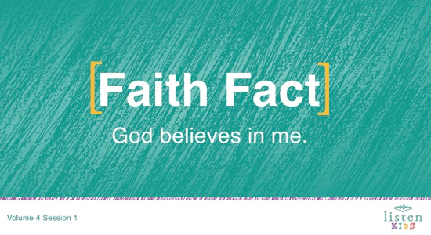
Can you say that with me on the count of 3? 1, 2, 3. God believes in me.
Let’s do it one more time. God believes in me. Great job!
Rules Review (Optional)
Great job! Who wants to have fun today? (Group response) I want to have fun, too. Before we get started, we need to make sure that we all know the rules. Let’s watch the video now.
• Play Rules Video.

Game
Gotcha
Now that we’ve talked about what we’re going to explore today, who wants to play a game? (Group response)
Ok, let’s play Gotcha. This is a fun game of elimination tag. One person will be “It” and will have one minute to tag other kids. If you get tagged, you are out and must go stand by the wall. Are you ready?
• Select or ask for a volunteer to be “It.”
• Play the Countdown60 Video–60 seconds.
• Say, “Go!” when you start the Countdown Video.
• When the countdown reaches zero, say, “Freeze!”
• Repeat as time allows.
Wow, that was a lot of fun! You all did a great job!
In today’s Bible story, you will learn about a man named Gideon. When God led Gideon to do a sneak attack in the middle of the night, the enemy was caught off guard. The Midianites were terrified and rushed around, shouting as they ran to escape. It was complete chaos. Like our game of Gotcha, every person was fleeing trying to save themselves from Gideon.

Worship
Now, it’s time to praise Jesus! Are you ready? Get on your feet. Here we go.
• Lead the kids in singing one or two praise songs. See suggestions at the beginning of the session.

Bible Lesson
Have you ever thought about how you’re going to do all that God tells you to do? I know I have. I know the best place to look to find the answer. Do you know what it is? (Group response) It’s in God’s Word, also known as the Bible. (Hold up your Bible.) Before we get started in God’s Word, let’s take a moment to pray and invite God to be with us.
Prayer
Dear God, thank You for being with us and believing in us. Help us to know You more as we learn from the Bible. Amen.
Video Intro
As we get started with our Bible story, let’s check in with our Challenge Accepted friends, Dash and Austin, to see what they’re up to!
• Play Bible Lesson Video A.
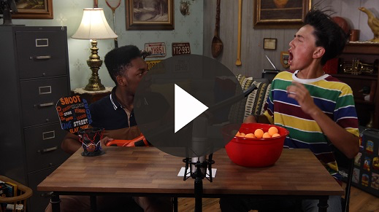
Wow! Would you like to accept that challenge? (Group response) That’s such a fun lead-in to our Bible story today!
Bible Story
(Open the Bible to Judges.) Last time, we learned how God helped Joshua and the Israelites defeat the city of Jericho. God gave the Israelites the land He had promised them. Then Joshua made sure that every one of the twelve tribes of Israel had their own land in the Promised Land. After Joshua died, the people eventually stopped serving God because they forgot about Him and everything He had done for their families.
This next period of time in Israel’s history is often called the time of the judges. During this time, the Israelites didn’t have an official leader like a king; instead, God appointed different people at different times to help guide, unite, and defend the Israelites through different challenges.
There were more than a dozen judges that God raised up at different times to help Israel. Each time God chose a judge to represent Israel, the nation flourished and the people were faithful in following God. Unfortunately, that change never lasted long. The people of Israel lost their way, disobeyed God, and ended up in big trouble time and time again! Eventually, they cried out to God for help. He heard them and answered their prayers by appointing a new judge.
Today’s story begins during a time when Israel was between judges and they were in trouble. Let’s read Judges 6:1–2.
• Read Judges 6:1–2.
The Midianites were bullies, and they had been picking on the Israelites so badly that the Israelites had to hide. Some of them hid in caves! The Midianites would steal all of the Israelites’ food and animals so they had nothing left to eat. The Israelites cried out to God for help!
• Show the Bible Lesson Slide 1.
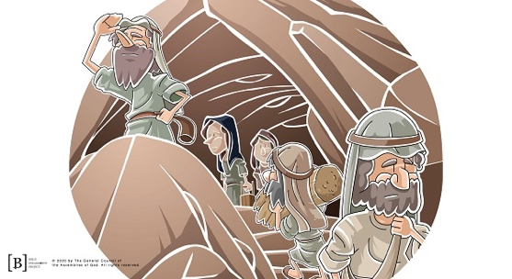
Now Gideon enters the story. He was hiding from the Midianites, preparing grain in the winepress, when all of a sudden something very surprising happened.
• Read Judges 6:12.
Imagine that you’re working on your homework and then boom! There’s the angel of the Lord, calling you a mighty hero! What would your reaction be? (Group response)
• Show the Bible Lesson Slide 2.
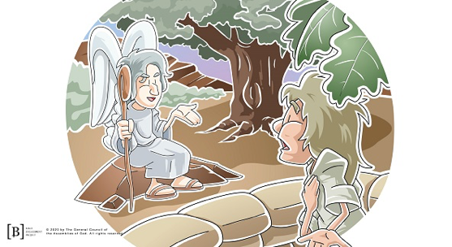
Gideon was confused, and he asked the angel why the Israelites were in so much trouble if God was really with them. Then, he got a shock. The angel of the Lord told Gideon that he was being sent to defeat the enemy and rescue Israel!
Now, Gideon was afraid. You see, Gideon didn’t feel very important or very brave. He was from the weakest clan in his tribe, and he thought he was the least in his family. How could he rescue Israel? Not possible! Then, the angel of the Lord gave Gideon the answer to how he would do this. Let’s read Judges 6:16.
• Read Judges 6:16.
God believed in Gideon, but Gideon still wasn’t convinced and confident that God really wanted to use him. Gideon asked God to give him signs. God proved His power to Gideon using a wool fleece.
• Show the Bible Lesson Slide 3.
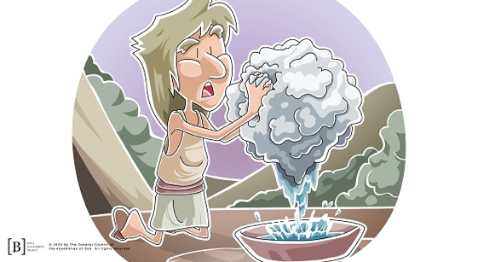
Gideon set out the fleece in the evening, and he asked God to make the fleece wet from the dew but keep the ground around it dry. God was patient with Gideon and He did exactly what Gideon asked.
Gideon still wasn’t convinced! He had one last test for God. This time Gideon put out the fleece overnight and asked God to make the fleece dry but keep the ground around it wet. God believed in Gideon, and He fulfilled his request.
So, Gideon rounded up an army of thirty-two thousand men and went to attack the Midianites. First, God told Gideon he had too many soldiers. So God had Gideon send home anyone who was afraid. After the frightened men went home, there were only ten thousand warriors left. Then God said that there were still too many soldiers.
Gideon must’ve been wondering how you could have too many soldiers in your army. After all, there were so many Midianites that you couldn’t even count their camels.
God wasn’t worried about defeating the Midianites. He wanted to make sure everyone knew that the Israelites were saved by the God they served and not by their own strength.
So, God had Gideon bring the men down to a stream and had the men get a drink of water from the stream. Then, He had Gideon separate the warriors into two groups. The first group would be for men who used their hands as a cup for the water and lapped it up with their tongue like dogs. The second group were the soldiers who kneeled down and drank straight from the stream with their mouths.
• Show the Bible Lesson Slide 4.
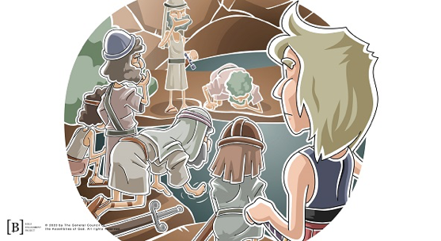

Only three hundred men drank from their hands. The rest drank straight from the stream. God was going to send one group home. Do you think He sent the group of three hundred men home? Or the big group of 9,700? (Group response) He sent the group of 9,700 home! Now, there were only three hundred men. Gideon must have thought he was in big trouble.
The Midianites were camped in the valley below Gideon’s men. Gideon was afraid that he really didn’t have enough men, so God told him to sneak down into the Midianite camp and listen to what the Midianites were saying. Gideon and his servant, Purah, quietly crept down into the camp and listened.
• Show the Bible Lesson Slide 5.
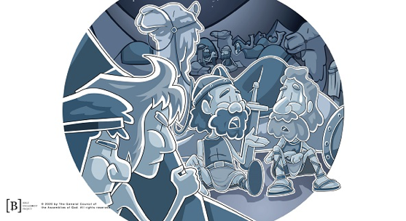
Gideon heard one of the Midianites say that he had a scary dream. The enemy army was afraid because they believed that the dream meant that God was going to give victory to Gideon and his men. How do you think that made Gideon feel? (Group response) Let’s find out what Gideon did.
• Read Judges 7:15.
Gideon divided his men into three groups and gave them some supplies. What kind of items do you think he gave them? (Group response) He didn’t give them weapons; instead, he gave each man a ram’s horn, a clay jar, and a torch inside of the jar.
• Show the Bible Lesson Slide 6.
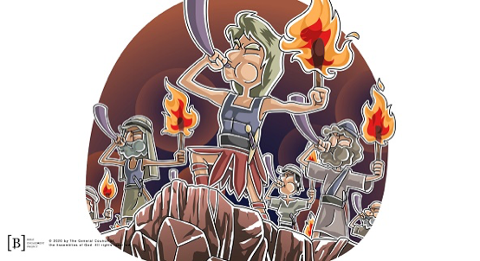
What do you think they could do with these things? They don’t seem like things that would help you win a battle. But, Gideon had a plan. He led his men to the edge of the Midianite camp and told them to follow his lead.
The three groups of soldiers spread out around the camp. Then Gideon and his army blew their ram horns and smashed their clay jars. They raised their torches. All the men began to do what Gideon did. They all shouted, “For the Lord and for Gideon!” (Judges 7:18).
While the three hundred men stood around the camp shouting, the Midianites were terrified and they all began to run away. As they ran, they started to fight each other with their swords. The Israelites had won the battle and didn’t even have to fight. God had made the way for victory. God believed in Gideon not because of who Gideon was by himself, but because God was with him!
Teaching Time
God is omnipotent, which means “all powerful.” He can do whatever He chooses. He doesn’t need thousands of men to win a battle. He doesn’t even need weapons! He can do what He wants, when He wants. However, God picked Gideon to be part of His plan for His people.
Just as God believed in Gideon enough to pick him to lead the rescue of the Israelites, God believes in you. He knows everything about you. He even knows what you’re afraid of. He says He will always be with you. He will never leave you.
Maybe there’s something you know you should do, but you’ve been afraid to do it. God believes in you. He is with you! You can do whatever He tells you to do. Even when you don’t feel good enough, you can know that He is all powerful. He is on your side, and when God is on your side, you don’t need to be afraid.
• Show the Faith Fact Slide.
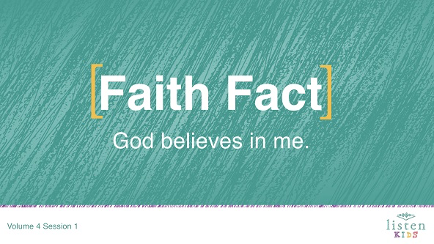
Say the Faith Fact with me: God believes in you. Great job!
Faith Verse
God picks you today. He has a plan for your future and wants you to choose to follow Him. If you do, He will be with you every day. Whenever you’re feeling like you’re not good enough or when you are afraid, remember our Faith Verse. Let’s learn the actions together.
• Play Faith Verse Video.
Isaiah 41:10 (NLT)
“Don’t be afraid, for I am with you. Don’t be discouraged, for I am your God. I will strengthen you and help you. I will hold you up with my victorious right hand.”

Prayer and Response
Consider playing a worship song softly in the background while kids pray.
Let’s take a couple of moments to worship and talk with God. He chose Gideon to do some pretty amazing things, and He wants to use you, too! Close your eyes and ask God to speak to your heart and show you something He wants you to do. It probably won’t be to lead an army, but it will still be important, because it’s a job God wants you to do! Let’s pray.
• Give kids time to pray. Kids may start singing the worship song. This is okay as long as it isn’t distracting others from praying.
Worship Song
Play a worship song.
Video Wrap-Up
Before we go to our Small Group activities, let’s see how Dash and Austin’s challenge worked out.
• Play Bible Lesson Video B.
Wow! I don’t know about you, but I’m ready to accept the challenge and trust that God can do some amazing things in and through my life just like He did for Gideon!
• Show the Faith Fact Slide.
Say it with me. God believes in me. Let’s do it one more time on the count of three. 1, 2, 3. God believes in me. Thanks for a great time learning about God together.
• Dismiss kids to Small Group time or to go home if your group time ends here.

Small Group
30 Minutes
This section can be done in conjunction with the large group, or on its own if you do small groups with your kids. During Small Group time, the goal is to connect the kids with the Word of God and to each other. All activities are led by the small group leader.

Group Connection
Which One?
You Will Need
- Small Group Group Connection page
- 3 cups, one set per group
- Tape
Getting Ready
- Print the Small Group Group Connection page and cut apart the torches.
- Tape the torch inside one of the cups.

When Gideon and his army went to the enemy camp, they carried clay jars with torches hidden inside. This was not something soldiers usually did. Gideon might have thought this plan was a bit odd. But Gideon trusted God and did what He said. Sometimes, God’s plans might not make sense to us either, but when we follow Him, we can trust that God believes in us and is on our side.
We are going to play a little game. I am going to mix up these cups and you are going to choose which one you think has the torch.
• Reveal the inside of each cup before you mix them up. Allow each kid to guess which cup has the torch inside.
Nice guessing! Let’s try it again.
• Repeat as time allows.
• For extra fun, allow the kids to mix up the cups.

Bible Lesson Recap
You Will Need
- Bible, one per kid

No prep needed for this activity.

Bible Story Review: Judges 6:11–16, 36–40.
Time and time again, we read in the Bible how God chooses to use people we would never expect. Gideon didn’t feel very important or very brave. He was from the weakest clan in his tribe and he felt he was the least in his family. Let’s read how God saw him differently.
• Divide the Bible reading into smaller chunks for volunteers to read aloud if needed.
What is one thing that you remember about our Bible story? (Allow responses.)
Faith Fact
In the same way that God believed in Gideon enough to pick him to lead the rescue of the Israelites, God believes in you. Point to yourself and say our Faith Fact now.
• Show the Faith Fact Slide.
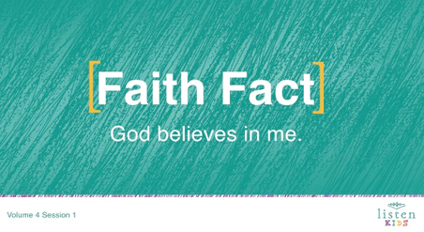
God believes in me.

Group Discussion
Feel free to use all or just a few questions as a jumping-off place for good discussion. Questions marked with * are designed for more conversation. Adjust the questions based on the age or maturity of your group. Typically, older kids will be able to dive a little deeper than younger ones.
Questions
Who was bullying the Israelites?
* Have any of you ever been bullied? How did it make you feel?
The Israelites asked God to help them. God picked Gideon to help rescue the Israelites because God believed in Gideon. How did God describe Gideon?
How did Gideon feel about himself?
How did Gideon know God was going to help him?
* Has God ever told you to do something hard? If so, like what?
God tells us to forgive people. Is that easy to do?
* What are other things God tells us to do that are hard?

Application and Response
Imagine you were Gideon and had witnessed what God had done. These mean bullies, the Midianites, that had once been terrifying the Israelites, were now conquered. What would you say to God? (Allow responses.)
One way we can show our love for God is by praising Him. When we worship God, we are expressing our love to God for all He is and all He has done for us. It’s important to take time to thank God!
God believed in Gideon and picked him to help rescue the Israelites. God believes in you, too! When we trust and obey God’s plan for our lives, God can use us every day!
Make It a Habit
Select a simple visual reminder of the session’s Faith Fact.
We need to make it a habit to remember what we’ve learned about God today. Gideon and his men used jars when they surrounded the Midianites. Every time you see a jar of something, I want you to remember that God chose Gideon because God believed in him and God believes in you, too!
Let’s pray and ask God to help us.
Prayer
Dear God, thank You for believing in me. Help me to not be afraid and trust You just like Gideon! Amen.

Faith Verse Review
You Will Need
- Torch, one per group
Getting Ready
- Create a torch using paper towel tubes and colored tissue paper (red, yellow, and orange to represent fire), one per group.

Our Faith Verse for today is Isaiah 41:10. It tells us that we do not need to be afraid because God is with us and He will help us. When we know God’s Word, He can bring a verse or Bible story to mind just when we need it.
• Show the Faith Verse Slide.
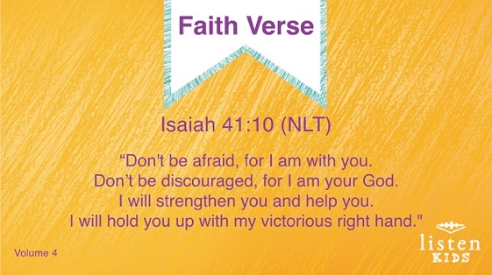
Isaiah 41:10 (NLT)
“Don’t be afraid, for I am with you. Don’t be discouraged, for I am your God. I will strengthen you and help you. I will hold you up with my victorious right hand.”
Faith Verse Fun
Pass the Torch
Okay kids, it’s time to play Pass the Torch! This game is played similar to Hot Potato. In this game, when the torch is passed to you, you have to say the next word in the Faith Verse. I’ll start the Faith Verse by saying, “Don’t.” Then, I am going to pass the torch to someone. The next person should say, “be.” We will keep passing the torch around the circle as we practice our Faith Verse.
• Have kids sit in a circle.
• Practice saying the Faith Verse a couple of times as the kids pass the torch.
• After practicing a few times, turn it into a game.
I’m going to start again, but this time, if you forget your word or say the wrong word, you are out. Last person remaining wins!
• When a kid forgets a word or says an incorrect word, he or she is out. Start off slow and try to speed up. Play continues until only one player is left.
Great job! See how much fun it can be learning God’s Word?

Creative Activity
Torch in a Jar
You Will Need
- Small Group Activity Page (2 pages), one per kid
- Activity Page 3
- Scissors
- Glue sticks
- Markers or crayons
Getting Ready
- Print the Small Group Activity Page (2 pages), one per kid.
- Print Activity Page 3, so each kid can have a torch.

You are going to create your own hidden torch in a jar. The first step is to cut out the jar along the solid line. (Help kids cut correctly.) Next, you fold the paper along the dotted line. These will be the flaps. Then, you will glue the jar to your activity page. Be careful not to glue down the flaps. Finally, you will glue your torch inside of the jar. (Kids can color their torches as time allows.)
Now you can use this jar and torch to tell your family and friends how God believed in Gideon and picked him to help rescue the Israelites!
Prayer
Dear God, thank You for helping us learn from Your Word, the Bible. Thank You for believing in us. Help us to remember this week just how much You love us. Amen.

Faith Fact Recap
• Display the Faith Fact Slide as parents are coming into the room.
• Maximize the time you have with your kids so that parents see what their kids have learned. Have the kids repeat the Faith Fact and then dismiss them to their parents.
• Show the Faith Fact Slide.
One thing I want you to remember from today is our Faith Fact. Let’s say it together: God believes in me.

Dismissal
• Send home the Small Group Activity Page.
• Remind parents that there are Family Devotions available on the app to do with their kid.
• Tell everyone the date and time for the next session.

